Module1_0
AdrienM
2026-05-21

Workshop 1 - Introduction to R and RStudio
source(here::here("Workshop 1", "workshop1.R"))

Worshop 2 - Data Visualization with ggplot2
#New chunk shortcuts
Comd + opt I Crtl + Alt I
library(tidyverse)
## ── Attaching core tidyverse packages ──────────────────────── tidyverse 2.0.0 ──
## ✔ dplyr 1.1.4 ✔ readr 2.1.5
## ✔ forcats 1.0.0 ✔ stringr 1.5.1
## ✔ ggplot2 4.0.0 ✔ tibble 3.2.1
## ✔ lubridate 1.9.4 ✔ tidyr 1.3.1
## ✔ purrr 1.0.4
## ── Conflicts ────────────────────────────────────────── tidyverse_conflicts() ──
## ✖ dplyr::filter() masks stats::filter()
## ✖ dplyr::lag() masks stats::lag()
## ℹ Use the conflicted package (<http://conflicted.r-lib.org/>) to force all conflicts to become errors
mpg
## # A tibble: 234 × 11
## manufacturer model displ year cyl trans drv cty hwy fl class
## <chr> <chr> <dbl> <int> <int> <chr> <chr> <int> <int> <chr> <chr>
## 1 audi a4 1.8 1999 4 auto… f 18 29 p comp…
## 2 audi a4 1.8 1999 4 manu… f 21 29 p comp…
## 3 audi a4 2 2008 4 manu… f 20 31 p comp…
## 4 audi a4 2 2008 4 auto… f 21 30 p comp…
## 5 audi a4 2.8 1999 6 auto… f 16 26 p comp…
## 6 audi a4 2.8 1999 6 manu… f 18 26 p comp…
## 7 audi a4 3.1 2008 6 auto… f 18 27 p comp…
## 8 audi a4 quattro 1.8 1999 4 manu… 4 18 26 p comp…
## 9 audi a4 quattro 1.8 1999 4 auto… 4 16 25 p comp…
## 10 audi a4 quattro 2 2008 4 manu… 4 20 28 p comp…
## # ℹ 224 more rows
#first ggplot
ggplot(data = mpg) +
geom_point(mapping = aes(x = displ, y = hwy))
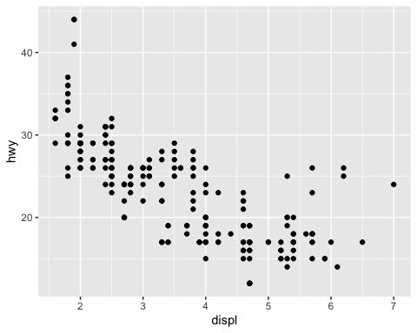
ggplot(data = mpg) +
geom_point(mapping = aes(x = displ, y = hwy, colour = class))
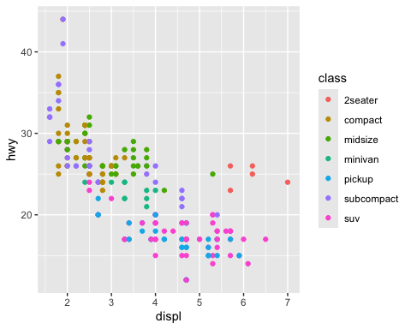 #change point color by class
ggplot(data = mpg) +
geom_point(mapping = aes(x = displ, y = hwy, size = class))
## Warning: Using size for a discrete variable is not advised.
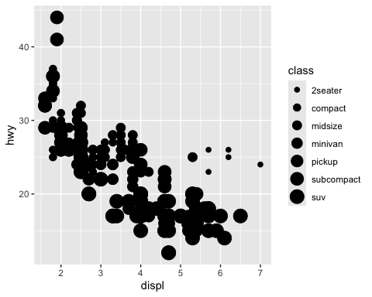
ggplot(data = mpg) +
geom_point(mapping = aes(x = displ, y = hwy, alpha = class))
## Warning: Using alpha for a discrete variable is not advised.
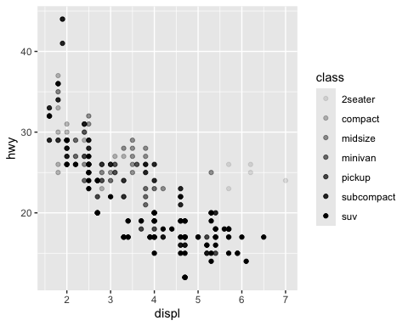 #change point shape by class
ggplot(data = mpg) +
geom_point(mapping = aes(x = displ, y = hwy), color = "blue")
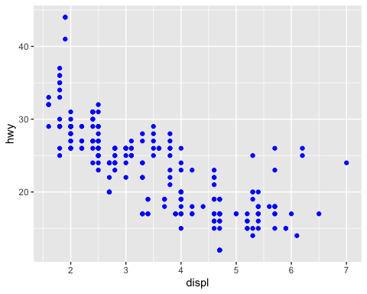
library(ggplot2)
ggplot(data = mpg) +
geom_point(
mapping = aes(
x = displ,
y = hwy,
colour = displ < 5
)
)
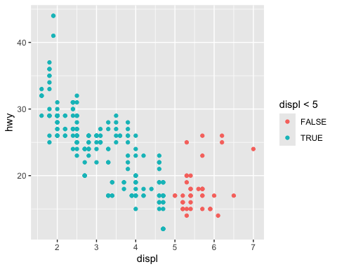 #facet and panel plots
ggplot(data = mpg) +
geom_point(mapping = aes(x = displ, y = hwy)) +
facet_wrap(~ class, nrow = 2)
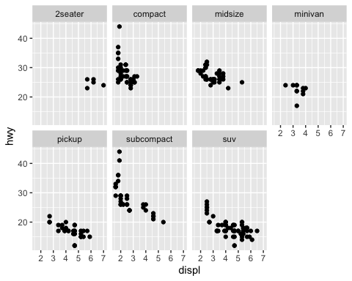
ggplot(data = mpg) +
geom_point(mapping = aes(x = displ, y = hwy)) +
facet_grid(drv ~ cyl)
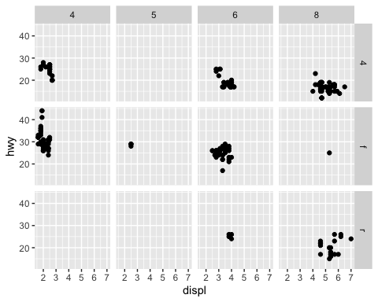 #Fitting simple lines
ggplot(data = mpg) +
geom_point(mapping = aes(x = displ, y = hwy))

ggplot(data = mpg) +
geom_smooth(mapping = aes(x = displ, y = hwy))
## `geom_smooth()` using method = 'loess' and formula = 'y ~ x'
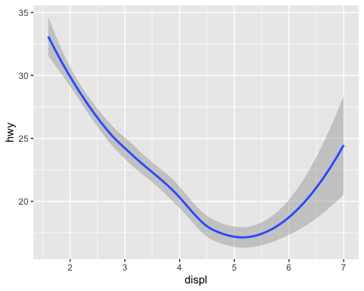
ggplot(data = mpg) +
# geom_point(mapping = aes(x = displ, y = hwy)) # points horrible
geom_smooth(mapping = aes(x = displ, y = hwy)) # try smooth line
## `geom_smooth()` using method = 'loess' and formula = 'y ~ x'

ggplot(data = mpg) +
geom_smooth(mapping = aes(x = displ, y = hwy, linetype = drv))
## `geom_smooth()` using method = 'loess' and formula = 'y ~ x'
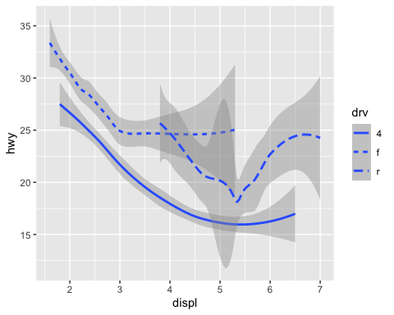
ggplot(data = mpg) +
geom_smooth(mapping = aes(x = displ, y = hwy, group = drv))
## `geom_smooth()` using method = 'loess' and formula = 'y ~ x'
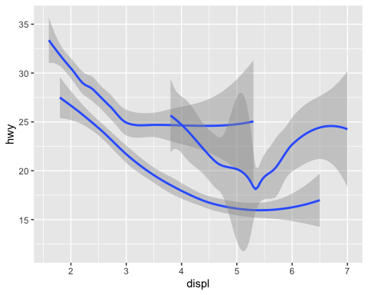
ggplot(data = mpg) +
geom_smooth(
mapping = aes(x = displ, y = hwy, color = drv),
show.legend = FALSE,
)
## `geom_smooth()` using method = 'loess' and formula = 'y ~ x'
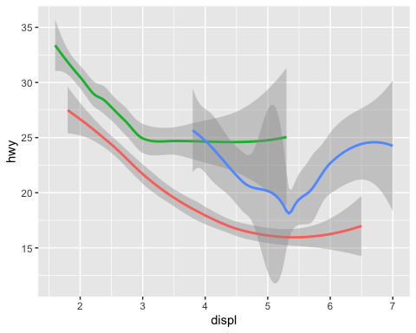
ggplot(data = mpg) +
geom_point(mapping = aes(x = displ, y = hwy)) +
geom_smooth(mapping = aes(x = displ, y = hwy))
## `geom_smooth()` using method = 'loess' and formula = 'y ~ x'
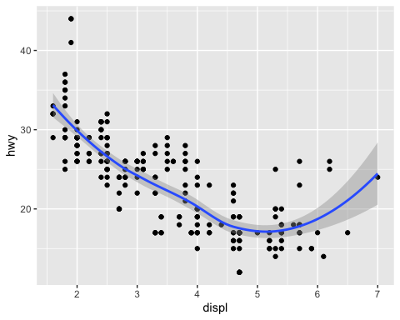
ggplot(data = mpg, mapping = aes(x = displ, y = hwy)) +
geom_point(mapping = aes(color = class)) +
geom_smooth()
## `geom_smooth()` using method = 'loess' and formula = 'y ~ x'
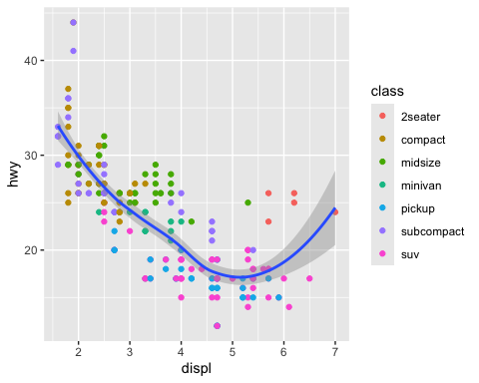
library(dplyr)
ggplot(data = mpg, mapping = aes(x = displ, y = hwy)) +
geom_point(mapping = aes(color = class)) +
geom_smooth(
data = filter(mpg, class == "subcompact"),
se = FALSE
)
## `geom_smooth()` using method = 'loess' and formula = 'y ~ x'
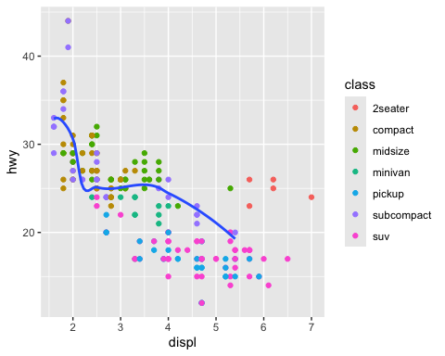
ggplot(data = mpg, mapping = aes(x = displ, y = hwy)) +
geom_point() +
geom_smooth()
## `geom_smooth()` using method = 'loess' and formula = 'y ~ x'

ggplot() +
geom_point(data = mpg, mapping = aes(x = displ, y = hwy)) +
geom_smooth(data = mpg, mapping = aes(x = displ, y = hwy))
## `geom_smooth()` using method = 'loess' and formula = 'y ~ x'
 #Transformations and Stats #Plotting statistics
ggplot(data = diamonds) +
geom_bar(mapping = aes(x = cut))
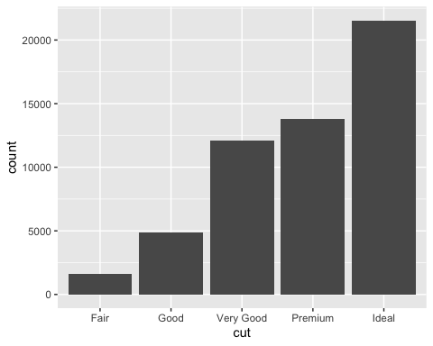
ggplot(data = diamonds) +
stat_count(mapping = aes(x = cut))

#overriding defaults in ggplot2
demo <- tribble(
~cut, ~freq,
"Fair", 1610,
"Good", 4906,
"Very Good", 12082,
"Premium", 13791,
"Ideal", 21551
)
demo
## # A tibble: 5 × 2
## cut freq
## <chr> <dbl>
## 1 Fair 1610
## 2 Good 4906
## 3 Very Good 12082
## 4 Premium 13791
## 5 Ideal 21551
ggplot(data = demo) +
geom_bar(mapping = aes(x = cut, y = freq), stat = "identity")
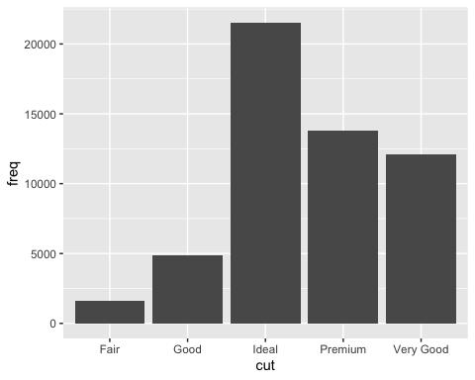
ggplot(data = diamonds) +
geom_bar(mapping = aes(x = cut, y = stat(prop), group = 1))
## Warning: `stat(prop)` was deprecated in ggplot2 3.4.0.
## ℹ Please use `after_stat(prop)` instead.
## This warning is displayed once every 8 hours.
## Call `lifecycle::last_lifecycle_warnings()` to see where this warning was
## generated.
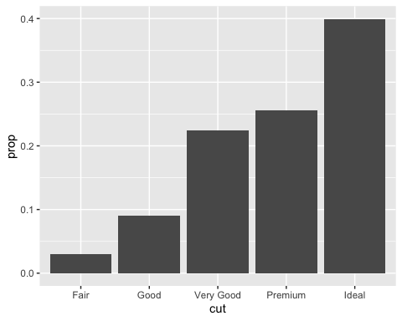
#> Warning: `stat(prop)` was deprecated in ggplot2 3.4.0.
#Plotting statistical details
ggplot(data = diamonds) +
stat_summary(
mapping = aes(x = cut, y = depth),
fun.min = min,
fun.max = max,
fun = median
)
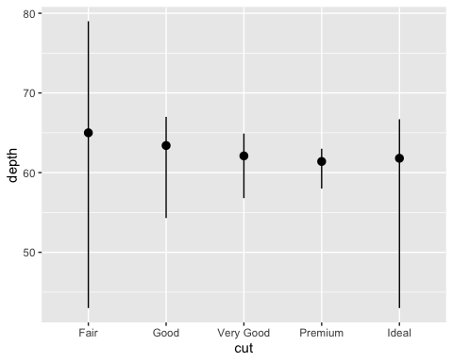
#Aestestic adjustements
ggplot(data = diamonds) +
geom_bar(mapping = aes(x = cut, colour = cut))
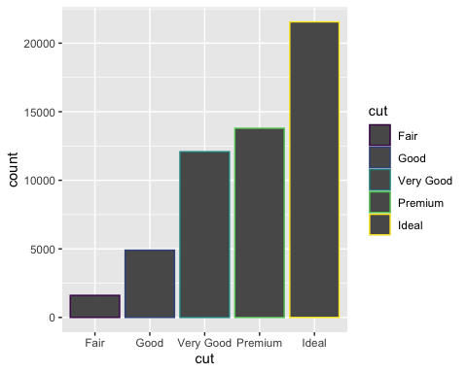
ggplot(data = diamonds) +
geom_bar(mapping = aes(x = cut, fill = cut))
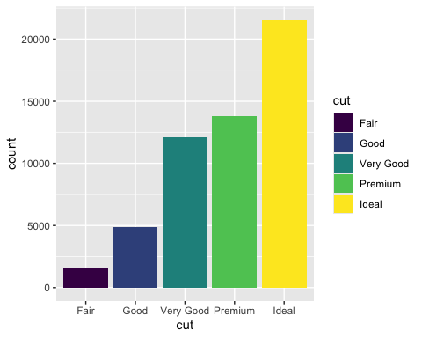
ggplot(data = diamonds) +
geom_bar(mapping = aes(x = cut, fill = clarity))
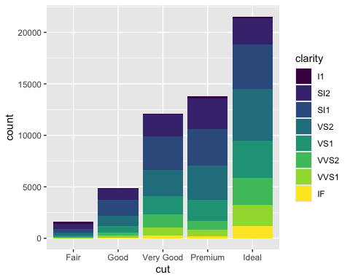
#To alter transparency (alpha)
ggplot(data = diamonds, mapping = aes(x = cut, fill = clarity)) +
geom_bar(alpha = 1/5, position = "identity")
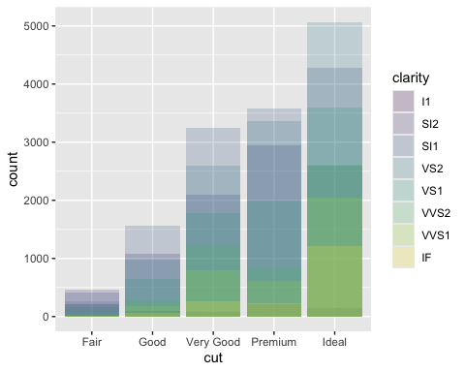
#To color the bar outlines with no fill color
ggplot(data = diamonds, mapping = aes(x = cut, colour = clarity)) +
geom_bar(fill = NA, position = "identity")
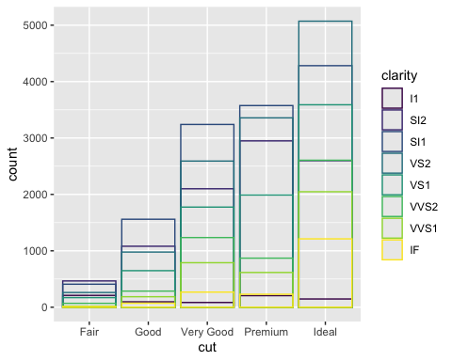
ggplot(data = diamonds) +
geom_bar(mapping = aes(x = cut, fill = clarity), position = "fill")
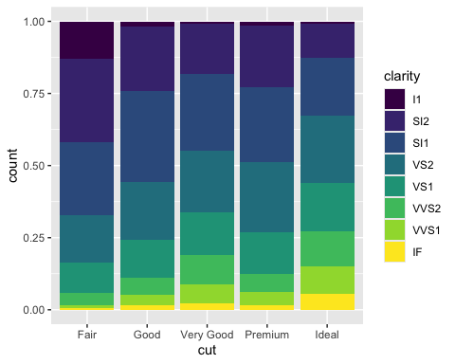
ggplot(data = diamonds) +
geom_bar(mapping = aes(x = cut, fill = clarity), position = "dodge")
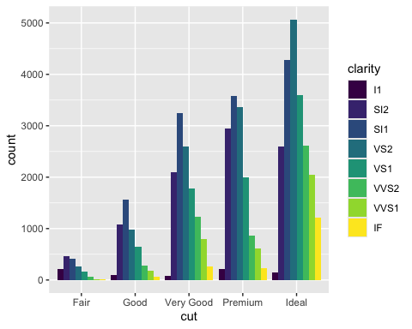
ggplot(data = mpg) +
geom_point(mapping = aes(x = displ, y = hwy), position = "jitter")
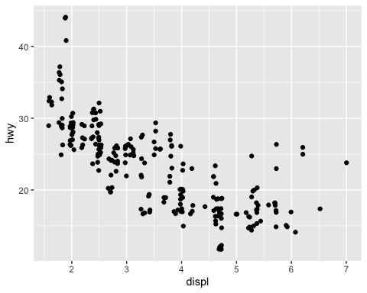
#The layered grammar of graphics
ggplot(data = mpg) +
geom_point(
mapping = aes(x = displ, y = hwy, color = class),
stat = "identity",
position = "identity"
)


Workshop 3 - R studio to github
library(usethis)
use_git_config(user.name = "MESSEAUD13", user.mail = "adriencharleslouis.messeaud@my.jcu.edu.au")

Workshop 4
# Load tidyverse (if not already loaded)
library(tidyverse)
# Sample coral data
coral_monitoring <- tibble(
site = c("Site_A", "Site_B", "Site_C"),
depth_m = c(12, 35, 8)
)
# Classify depth using if_else
coral_monitoring <- coral_monitoring %>%
mutate(zone = if_else(depth_m > 30, "Deep Reef", "Shallow Reef"))
coral_monitoring <- coral_monitoring %>%
mutate(reef_category = case_when(
depth_m < 10 ~ "Lagoon / Flats",
depth_m <= 30 ~ "Crest / Slope",
depth_m > 30 ~ "Mesophotic / Deep",
TRUE ~ "Unclassified" # Catch-all remainder
))
# Classic loop anatomy
for (year in 2020:2024) {
print(paste("Processing climate data for year:", year))
}
## [1] "Processing climate data for year: 2020"
## [1] "Processing climate data for year: 2021"
## [1] "Processing climate data for year: 2022"
## [1] "Processing climate data for year: 2023"
## [1] "Processing climate data for year: 2024"
# Loop across index sequences
transect_lengths <- c(50, 100, 25, 75)
for (i in seq_along(transect_lengths)) {
print(paste("Transect number", i, "measures", transect_lengths[i], "metres."))
}
## [1] "Transect number 1 measures 50 metres."
## [1] "Transect number 2 measures 100 metres."
## [1] "Transect number 3 measures 25 metres."
## [1] "Transect number 4 measures 75 metres."
site_areas <- c(144, 400, 625)
results <- numeric(length(site_areas)) # Must build an empty container first
for(i in seq_along(site_areas)) {
results[i] <- sqrt(site_areas[i])}
library(purrr)
# Map directly and define your expected output type explicitly
mapped_results <- map_dbl(site_areas, sqrt)
# Iterate a summary function over split lists of data
iris %>%
split(.$Species) %>%
map(~summary(.x))
## $setosa
## Sepal.Length Sepal.Width Petal.Length Petal.Width
## Min. :4.300 Min. :2.300 Min. :1.000 Min. :0.100
## 1st Qu.:4.800 1st Qu.:3.200 1st Qu.:1.400 1st Qu.:0.200
## Median :5.000 Median :3.400 Median :1.500 Median :0.200
## Mean :5.006 Mean :3.428 Mean :1.462 Mean :0.246
## 3rd Qu.:5.200 3rd Qu.:3.675 3rd Qu.:1.575 3rd Qu.:0.300
## Max. :5.800 Max. :4.400 Max. :1.900 Max. :0.600
## Species
## setosa :50
## versicolor: 0
## virginica : 0
##
##
##
##
## $versicolor
## Sepal.Length Sepal.Width Petal.Length Petal.Width Species
## Min. :4.900 Min. :2.000 Min. :3.00 Min. :1.000 setosa : 0
## 1st Qu.:5.600 1st Qu.:2.525 1st Qu.:4.00 1st Qu.:1.200 versicolor:50
## Median :5.900 Median :2.800 Median :4.35 Median :1.300 virginica : 0
## Mean :5.936 Mean :2.770 Mean :4.26 Mean :1.326
## 3rd Qu.:6.300 3rd Qu.:3.000 3rd Qu.:4.60 3rd Qu.:1.500
## Max. :7.000 Max. :3.400 Max. :5.10 Max. :1.800
##
## $virginica
## Sepal.Length Sepal.Width Petal.Length Petal.Width
## Min. :4.900 Min. :2.200 Min. :4.500 Min. :1.400
## 1st Qu.:6.225 1st Qu.:2.800 1st Qu.:5.100 1st Qu.:1.800
## Median :6.500 Median :3.000 Median :5.550 Median :2.000
## Mean :6.588 Mean :2.974 Mean :5.552 Mean :2.026
## 3rd Qu.:6.900 3rd Qu.:3.175 3rd Qu.:5.875 3rd Qu.:2.300
## Max. :7.900 Max. :3.800 Max. :6.900 Max. :2.500
## Species
## setosa : 0
## versicolor: 0
## virginica :50
##
##
##
# Function Definition
calculate_coral_mortality <- function(initial_count, surviving_count) {
# Logic safety switch using our conditional tools!
if (initial_count <= 0) {
stop("Initial count must be greater than zero.")
}
mortality_rate <- (initial_count - surviving_count) / initial_count
return(mortality_rate)
}

Utilizing your custom function
calculate_coral_mortality(initial_count = 120, surviving_count = 84)
## [1] 0.3
convert_temp_c_to_f <- function(celsius) {
if (celsius < -273.15) {
stop("Temperature cannot be below absolute zero (-273.15°C).")
}
fahrenheit <- (celsius * 9/5) + 32
return(fahrenheit)
}
# Valid test
convert_temp_c_to_f(25)
## [1] 77
library(tidyverse)
library(palmerpenguins)
# Load the penguins dataset
data(penguins)
# Create custom color palettes
species_colors <- c(
"Adelie" = "#FF6B6B",
"Chinstrap" = "#4ECDC4",
"Gentoo" = "#45B7D1"
)
# Generate boxplot comparing flipper_length_mm across species, faceted by island
penguins %>%
drop_na(flipper_length_mm) %>%
ggplot(aes(x = species, y = flipper_length_mm, fill = species)) +
geom_boxplot(alpha = 0.8, outlier.size = 2, outlier.alpha = 0.7) +
facet_wrap(~island, ncol = 3) +
scale_fill_manual(values = species_colors) +
labs(
title = "Flipper Length Distribution by Species and Island",
subtitle = "Palmer Penguins Dataset",
x = "Species",
y = "Flipper Length (mm)",
fill = "Species"
) +
theme_minimal() +
theme(
plot.title = element_text(size = 16, face = "bold", hjust = 0.5),
plot.subtitle = element_text(size = 12, hjust = 0.5, color = "gray60"),
axis.text.x = element_text(angle = 45, hjust = 1),
axis.title = element_text(size = 12, face = "bold"),
strip.text = element_text(size = 11, face = "bold"),
panel.grid.major.y = element_line(color = "gray90"),
legend.position = "bottom"
)
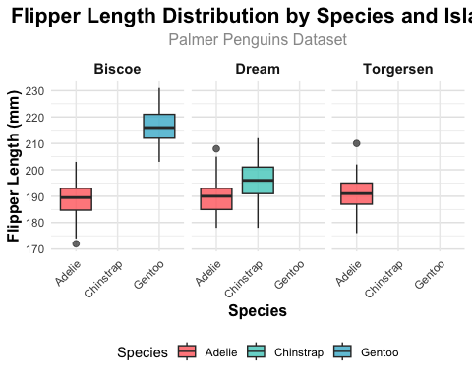
# Optional: Save the plot
ggsave("flipper_length_boxplot.png", width = 12, height = 6, dpi = 300)
library(tidyverse)
library(palmerpenguins)
# Load the penguins dataset
data(penguins)
# Create custom color palettes
species_colors <- c(
"Adelie" = "#FF6B6B",
"Chinstrap" = "#4ECDC4",
"Gentoo" = "#45B7D1"
)
# Generate scatter plot with linear regression trend lines
penguins %>%
drop_na(body_mass_g, flipper_length_mm) %>%
ggplot(aes(x = flipper_length_mm, y = body_mass_g, color = species, fill = species)) +
geom_point(size = 3, alpha = 0.6, shape = 21, color = "black", stroke = 0.5) +
geom_smooth(method = "lm", se = TRUE, alpha = 0.15, size = 1.2) +
scale_color_manual(values = species_colors) +
scale_fill_manual(values = species_colors) +
labs(
title = "Body Mass vs Flipper Length by Species",
subtitle = "Palmer Penguins Dataset with Linear Regression Trends",
x = "Flipper Length (mm)",
y = "Body Mass (g)",
color = "Species",
fill = "Species"
) +
theme_minimal() +
theme(
plot.title = element_text(size = 16, face = "bold", hjust = 0.5),
plot.subtitle = element_text(size = 12, hjust = 0.5, color = "gray60"),
axis.title = element_text(size = 12, face = "bold"),
axis.text = element_text(size = 10),
panel.grid.major = element_line(color = "gray90"),
panel.grid.minor = element_blank(),
legend.position = "bottom",
legend.title = element_text(face = "bold")
)
## Warning: Using `size` aesthetic for lines was deprecated in ggplot2 3.4.0.
## ℹ Please use `linewidth` instead.
## This warning is displayed once every 8 hours.
## Call `lifecycle::last_lifecycle_warnings()` to see where this warning was
## generated.
## `geom_smooth()` using formula = 'y ~ x'
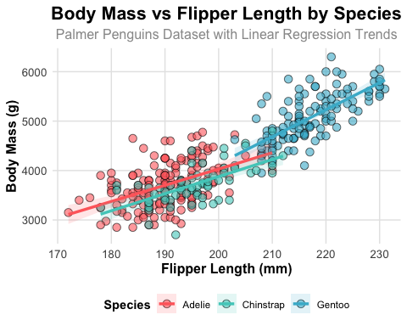
# Optional: Save the plot
ggsave("flipper_mass_regression.png", width = 10, height = 7, dpi = 300)
## `geom_smooth()` using formula = 'y ~ x'

